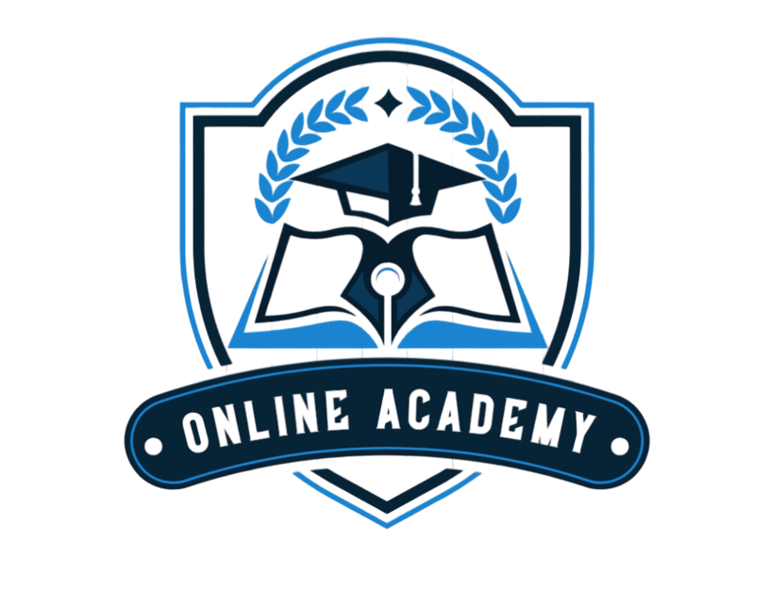Online Academy

**Table of Contents**

Team members 2

Topic 2

Stages of realization 2

Used technologies 2

Performed tasks 3

Future ideas 3

Algorithmic scheme 3

Team members

|  |  |
| --- | --- |
| **NAME** | **ROLE** |
| **Viкtoria Kupenova** | Scrum trainer |
| **Yana Ilcheva** | Back-end Developer |
| **Rostislav Nikolov** | Back-end Developer |
| **Мaria Bakumtseva** | Back-end Developer |
| **Arina Popova** | Back-end Developer |
| **Alexandra Zheleva** | QA Developer |

Topic

Our team made an app, that is like an online school. Through it, you can first read information on the various subjects and then take a test to check the knowledge you have already learned.

Картина, която съдържа текст, екранна снимка, Шрифт, линия

Описанието е генерирано автоматично

Stages of realization

Used technologies

* **Visual Studio** - for writing the code
* **Power Point** - for creating the presentation
* **Word** - for creating the documentation
* **Figma** - for creating the logo
* **Chrome** -for some ideas about the game and the design
* **GitHub** - for project synchronization
* **Git** -to commit our changes
* **C++** - for creating the game

Performed tasks

|  |  |
| --- | --- |
|  | Performed tasks |
| 1 | Created the basic design of the console app.  It is like an online school where you can learn and test yourself. |
| 2 | Created a menu.  There are five options: Revision, Start test, Information, Grades, Exit. |
| 3 | Created a submenu of the menus. |
| 4 | Created a presentation, documentation, and QA documents.  Created their designs. |

Future ideas

* Upgrade the console app functions to have more options
* Upgrade the design

Algorithmic scheme